Transitional Words
This structured list of commonly used English transition words — approximately 200, can be considered as quasi complete. It can be used (by students and teachers alike) to find the right expression. English transition words are essential, since they not only connect ideas, but also can introduce a certain shift, contrast or opposition, emphasis or agreement, purpose, result or conclusion, etc. in the line of argument.
The transition words and phrases have been assigned only once to somewhat artificial categories, although some words belong to more than one category.
There is some overlapping with prepositions and postpositions, but for the purpose of usage and completeness of this concise guide, I did not differentiate.
Agreement / Addition / Similarity
The transition words like also, in addition, and, likewise, add information, reinforce ideas, and express agreement with preceding material.

in the first place
not only ... but also
as a matter of fact
in like manner
in addition
coupled with
in the same fashion / way
first, second, third
in the light of
not to mention
to say nothing of
equally important
by the same token
again
to
and
also
then
equally
identically
uniquely
like
as
too
moreover
as well as
together with
of course
likewise
comparatively
correspondingly
similarly
furthermore
additionally

Opposition / Limitation / Contradiction
Transition phrases like but, rather and or, express that there is evidence to the contrary or point out alternatives, and thus introduce a change the line of reasoning (contrast).

although this may be true
in contrast
different from
of course ..., but
on the other hand
on the contrary
at the same time
in spite of
even so / though
be that as it may
then again
above all
in reality
after all
but
(and) still
unlike
or
(and) yet
while
albeit
besides
as much as
even though
although
instead
whereas
despite
conversely
otherwise
however
rather
nevertheless
nonetheless
regardless
notwithstanding

Cause / Condition / Purpose
These transitional phrases present specific conditions or intentions.

in the event that
granted (that)
as / so long as
on (the) condition (that)
for the purpose of
with this intention
with this in mind
in the hope that
to the end that
for fear that
in order to
seeing / being that
in view of
If
... then
unless

when
whenever
while

because of
as
since
while
lest
in case
provided that
given that
only / even if
so that
so as to
owing to
inasmuch as
due to

Examples / Support / Emphasis
These transitional devices (like especially) are used to introduce examples assupport, to indicate importance or as an illustration so that an idea is cued to the reader.

in other words
to put it differently
for one thing
as an illustration
in this case
for this reason
to put it another way
that is to say
with attention to
by all means

important to realize
another key point
first thing to remember
most compelling evidence
must be remembered
point often overlooked
to point out
on the positive side
on the negative side
with this in mind
notably
including
like
to be sure
namely
chiefly
truly
indeed
certainly
surely
markedly
such as

especially
explicitly
specifically
expressly
surprisingly
frequently
significantly
particularly
in fact
in general
in particular
in detail
for example
for instance
to demonstrate
to emphasize
to repeat
to clarify
to explain
to enumerate

Effect / Consequence / Result
Some of these transition words (thus, then, accordingly, consequently, therefore, henceforth) are time words that are used to show that after a particular time there was a consequence or an effect.
Note that for and because are placed before the cause/reason. The other devices are placed before the consequences or effects.

as a result
under those circumstances
in that case
for this reason
in effect
for
thus
because the
then
hence
consequently
therefore
thereupon
forthwith
accordingly
henceforth

Conclusion / Summary / Restatement
These transition words and phrases conclude, summarize and / or restate ideas, or indicate a final general statement. Also some words (like therefore) from the Effect / Consequence category can be used to summarize.

as can be seen
generally speaking
in the final analysis
all things considered
as shown above
in the long run
given these points
as has been noted
in a word
for the most part
after all
in fact
in summary
in conclusion
in short
in brief
in essence
to summarize
on balance
altogether
overall
ordinarily
usually
by and large
to sum up
on the whole
in any event
in either case
all in all

Obviously
Ultimately
Definitely

Time / Chronology / Sequence
These transitional words (like finally) have the function of limiting, restricting, and defining time. They can be used either alone or as part of adverbial expressions.

at the present time
from time to time
sooner or later
at the same time
up to the present time
to begin with
in due time
as soon as
as long as
in the meantime
in a moment
without delay
in the first place
all of a sudden
at this instant
first, second

immediately
quickly
finally
after
later
last
until
till
since
then
before
hence
since
when
once
about
next
now

formerly
suddenly
shortly
henceforth
whenever
eventually
meanwhile
further
during
in time
prior to
forthwith
straightaway

by the time
whenever

until now
now that

instantly
presently
occasionally

Many transition words in the time category (consequently; first, second, third; further; hence; henceforth; since; then, when; and whenever) have other uses.
Except for the numbers (first, second, third) and further they add a meaning of timein expressing conditions, qualifications, or reasons. The numbers are also used to add information or list examples. Further is also used to indicate added space as well as added time.

Space / Location / Place
These transition words are often used as part of adverbial expressions and have the function to restrict, limit or qualify space. Quite a few of these are also found in the Time category and can be used to describe spatial order or spatial reference.

in the middle
to the left/right
in front of
on this side
in the distance
here and there
in the foreground
in the background
in the center of

adjacent to
opposite to
here
there
next
where
from
over
near
above
below
down
up
under
further
beyond
nearby
wherever
around
between
before
alongside
amid
among
beneath
beside
behind
across

List of Transition Words

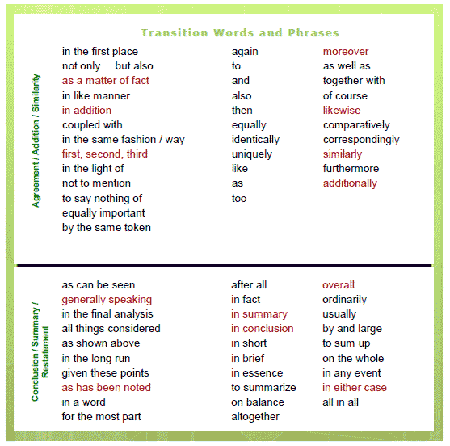

Usage of Transition Words in Essays
Transition words and phrases are vital devices for essays, papers or other literary compositions. They improve the connections and transitions between sentences and paragraphs. They thus give the text a logical organization and structure (see also: aList of Synonyms).
All English transition words and phrases (sometimes also called 'conjunctive adverbs') do the same work as coordinating conjunctions: they connect two words, phrases or clauses together and thus the text is easier to read and the coherence is improved.

Usage: transition words are used with a special rule for punctuation: a semicolon or a period is used after the first 'sentence', and a comma is almost always used to set off the transition word from the second 'sentence'.
Example 1:
People use 43 muscles when they frown; however, they use only 28 muscles when they smile.

Example 2:
However, transition words can also be placed at the beginning of a new paragraph or sentence - not only to indicate a step forward in the reasoning, but also to relate the new material to the preceding thoughts.
Use a semicolon to connect sentences, only if the group of words on either side of the semicolon is a complete sentence each (both must have a subject and a verb, and could thus stand alone as a complete thought).

